**Calling Customized /User Defined BAPI by Using Program # 01.1.**

***Program theme:*** *In this demo program you u can learn how to call the Customized/ User defined BAPI (Business Application Programming Interface) by using the calling program.*

**Step # 1:** Go to transaction code SE38 and create the executable program.

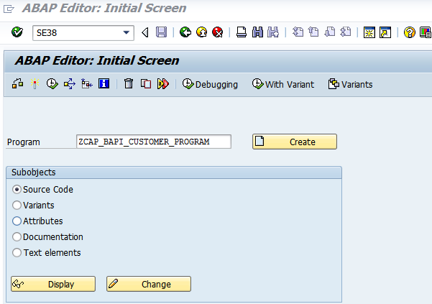

**Step # 2:** Provide the description and click on save.

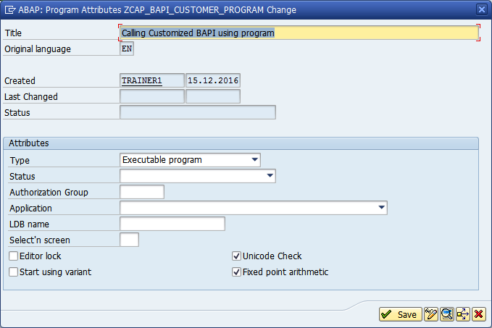

**Step # 3:** Save it in a package.

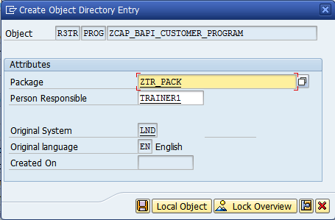

**Step # 4:** Write the Program logic.

*&---------------------------------------------------------------------*  
*& Report ZCAP_BAPI_CUSTOMER_PROGRAM  
*&---------------------------------------------------------------------*  
*&  
*&---------------------------------------------------------------------*  
REPORT ZCAP_BAPI_CUSTOMER_PROGRAM.  
*---------------------------------------------------------------------*  
*& Calling customized BAPI by using executable program  
* to display the customers info.  
*&---------------------------------------------------------------------*  
  
TABLES KNA1.  
  
TYPES: BEGIN OF TY_TAB2,     " Structure type  
         KUNNR TYPE KUNNR,   " Customer Number  
         NAME1 TYPE NAME1,   " Name  
         NAME2 TYPE NAME2,   " Name 2  
         ORT01 TYPE ORT01,   " City  
         LAND1 TYPE LAND1,   " Country Key  
         BUKRS TYPE BUKRS,   " Company Code  
         PERNR TYPE PERNR_D, " Personnel Number  
         AKONT TYPE AKONT,   "  Reconciliation Account in General Ledger  
       END OF TY_TAB2.  
  
DATA : IT_TAB2 TYPE STANDARD TABLE OF TY_TAB2,  " Internal Table  
       WA_TAB2 TYPE TY_TAB2.                    " Work are  
  
SELECT-OPTIONS S_KUNNR FOR KNA1-KUNNR.   " Select options for range of customers  
  
CALL FUNCTION 'BAPI_CUST_MASTER'   " Calling Customized BAPI  
  EXPORTING  
    I_KUNNR1 = S_KUNNR-LOW  
    I_KUNNR2 = S_KUNNR-HIGH  
* IMPORTING  
*   RETURN   =  
  TABLES  
    IT_TAB   = IT_TAB2.  
  
  
* Calling Customized BAPI using RFC  
  
*CALL FUNCTION 'BAPI_CUST_MASTER' DESTINATION 'LNDCLNT200' "RFC Name in SM59 T-code  
*  EXPORTING  
*    I_KUNNR1 = S_KUNNR-LOW  
*    I_KUNNR2 = S_KUNNR-HIGH  
** IMPORTING  
**   RETURN   =  
*  TABLES  
*    IT_TAB   = IT_TAB2.  
  
LOOP AT IT_TAB2 INTO WA_TAB2.  
  WRITE : / WA_TAB2-KUNNR,  
            WA_TAB2-NAME1,  
            WA_TAB2-NAME2,  
            WA_TAB2-ORT01,  
            WA_TAB2-LAND1,  
            WA_TAB2-BUKRS,  
            WA_TAB2-PERNR,  
            WA_TAB2-AKONT.  
ENDLOOP.

**Step # 5:** Execute the main program and provide the customer number lower limit and upper limit values and press the execute button (F8)

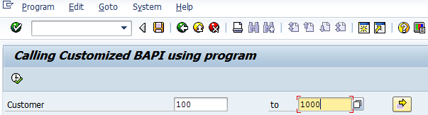

**Step # 6:** find the below output of the customers.

